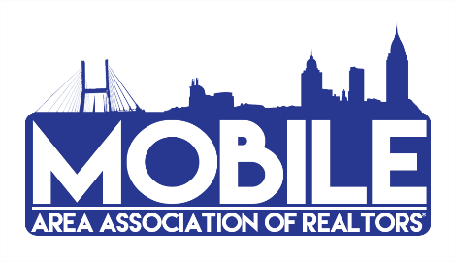
2020 Committee Participation Form
We’re gearing up for an amazing 2020, and we need YOU on our team! Sign up for a Committee to help sustain and promote the value and growth of our Association. We have many varied committees to choose from and we’re confident you’ll find the right fit.
NOTE: EVEN IF YOU WERE ON A COMMITTEE LAST YEAR, YOU MUST SIGN UP AGAIN THIS YEAR TO REMAIN ON THAT COMMITTEE!
COMMITTEES AND FORUMS:
GOVERNMENTAL AFFAIRS FORUM – Keep abreast of local, state and national political activity and policies which may affect private property ownership, the real estate profession or members of the Association. This monthly luncheon is open to the first 50 members that register online.
RPAC – Responsible for soliciting and collecting contributions for the Alabama REALTORS® Political Action Committee (RPAC), which supports pro-REALTOR® policy and candidates at the local, state, and federal level.
RPAC AUCTION – Responsible for soliciting items and contributions for the ARPAC Annual Auction to benefit Alabama REALTORS® Political Action Committee (RPAC).
COMMUNITY RELATIONS – Coordinates special community projects, i.e. school supply drives, serving meals to kids at Camp Rap-a-Hope and Camp Smile, blood drives, etc., while serving and promoting the REALTOR® image throughout the community.
EDUCATION – Helps coordinate classes and informational sessions to equip members with the tools needed to be a successful REALTOR® and the voice for Real Estate. The committee encourages class attendance, researches members’ educational needs, and monitors CE classes for compliance with AREC.
GRIEVANCE AND PROFESSIONAL STANDARDS – We are growing and training members for these committees. If you are interested in being considered for this group, please contact Stephanie@gcmls.com. Final approval is required by the Board of Directors.
FINANCE – Responsible for oversight and review of Financials for MAAR & GCMLS. If you are interested in being considered for this group, please contact Stephanie@gcmls.com. Final approval is required by the Board of Directors.
YPN (Young Professionals Network) – It serves as a resource for the next generation of REALTORS®, in terms of education, professionalism and networking.

To sign up for a 2020 committee, please complete the following and email to the Association office, MobileRealtors@gcmls.com.
NAME ____________________________________ COMPANY_______________________________________
EMAIL ADDRESS ________________________________________________ DATE_______________________
COMMITTEE AREA OF INTEREST _______________________________________________________________

