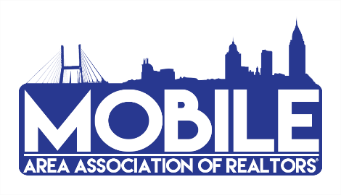

2022 Committee Participation Form
We’re gearing up for an amazing 2022, and we need YOU on our team! Sign up for a committee to help sustain and promote the value and growth of our Association. We have many varied committees to choose from and we’re confident you’ll find the right fit.
**NOTE: If you were on a committee last year, **YOU MUST SIGN UP AGAIN THIS YEAR to remain on that committee.

COMMITTEES AND FORUMS:

GOVERNMENTAL AFFAIRS FORUM – Keep abreast of local, state, and national political activity and policies which may affect private property ownership, the real estate profession, or members of the Association. This monthly luncheon is open to the first 50 members that register online.
RPAC – Responsible for soliciting and collecting contributions for the Alabama REALTORS® Political Action Committee (RPAC), which supports pro-REALTOR® policy and candidates at the local, state, and federal level.
RPAC AUCTION – Responsible for soliciting items and contributions for the ARPAC Annual Auction to benefit Alabama REALTORS® Political Action Committee (RPAC).
COMMUNITY RELATIONS – Coordinates special community projects, i.e. school supply drives, serving meals to kids at Camp Rap-a-Hope and Camp Smile, blood drives, etc., while serving and promoting the REALTOR® image throughout the community.
EDUCATION – Helps coordinate classes and informational sessions to equip members with the tools needed to be a successful REALTOR® and the voice for Real Estate. The committee encourages class attendance, research members’ educational needs, and monitors CE classes for compliance with AREC.
GRIEVANCE- monthly meetings consist of reviewing case studies and learning the process for Ethics and Arbitration. Annual training is required. If you are interested in being considered for this group, please contact Stephanie@gcmls.com. Final approval is required.
PROFESSIONAL STANDARDS – This committee requires prior, active participation on the Grievance committee. Annual training required.
FINANCE – Responsible for oversight and review of Financials for MAAR & GCMLS. If you are interested in being considered for this group, please contact Stephanie@gcmls.com. This is an appointed committee with limited seats.

To sign up for a 2022 committee, please complete the following and email to the Association office, MobileRealtors@gcmls.com.
NAME COMPANY EMAIL ADDRESS DATE COMMITTEE AREA OF INTEREST

